**Running PHPUnit tests after each commit**

Required Flow: -

Code Commit -> Jenkins Job trigger -> Runs PHPUnit test cases -> Output in a file -> Jenkins parse this file and checks if all cases have passed

-> If Yes, then Code is deployed / Build is complete

-> If No, then code is not deployed / Build fails.

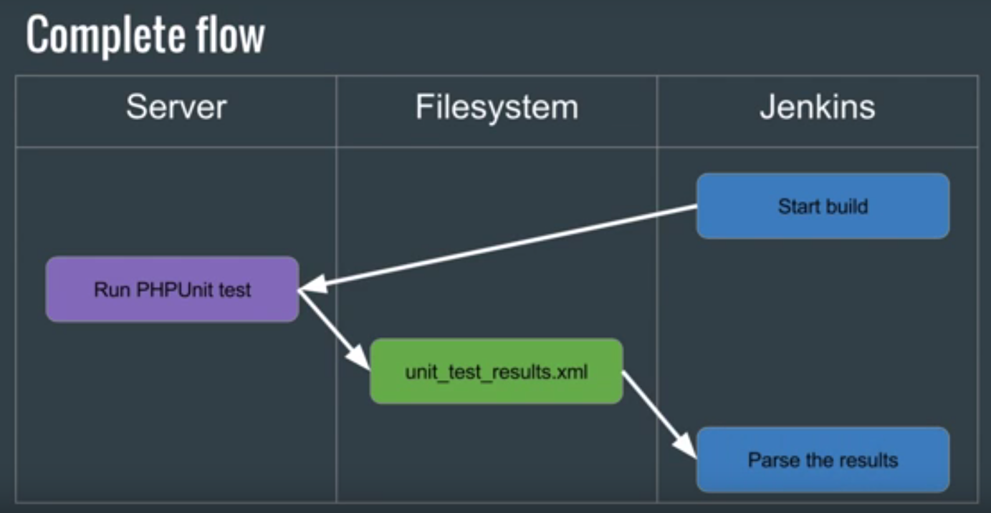

Required on Jenkins Server ->

1. Install PHPUnit Plugin
2. JUnit Plugin - JUnit output file(xml)

Sample Project ->

PHP Class  
  
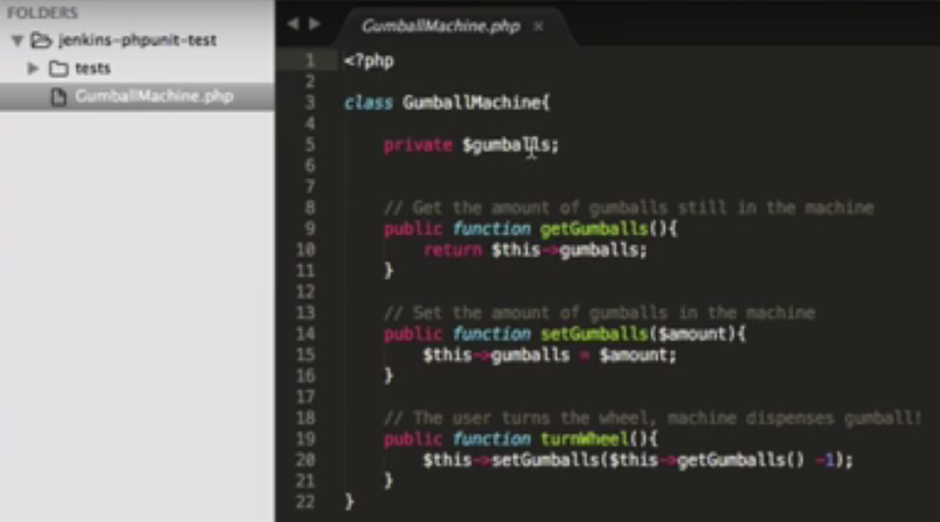

PHPUnit_Framework_TestCase

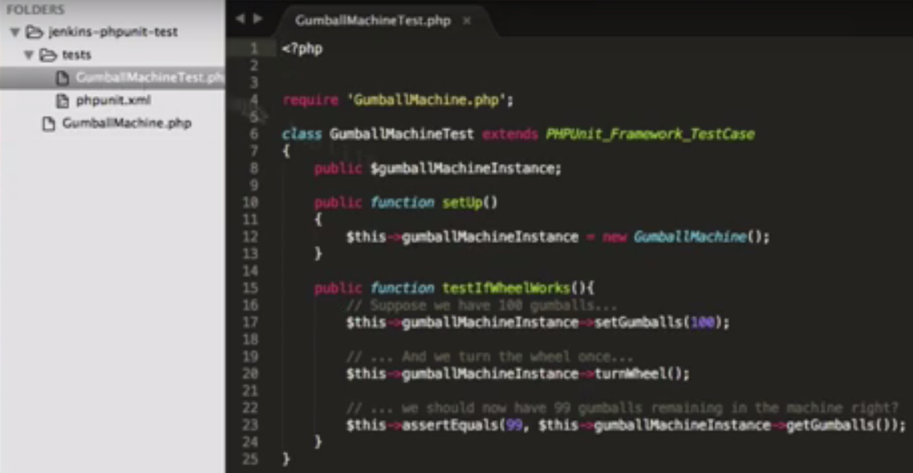

Set it up on Bit Bucket with same Folder structure.

This xml will basically run all the tests in the current directory –

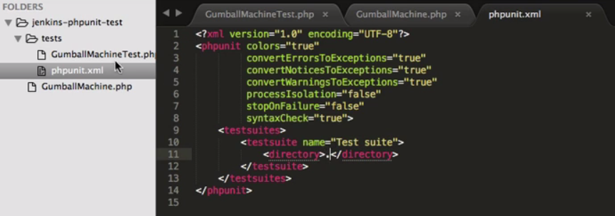

Set Up Job in Jenkins -

1. Sudo apt-get install phpunit
2. Verify the JUnit Plugin is installed

In the build section –

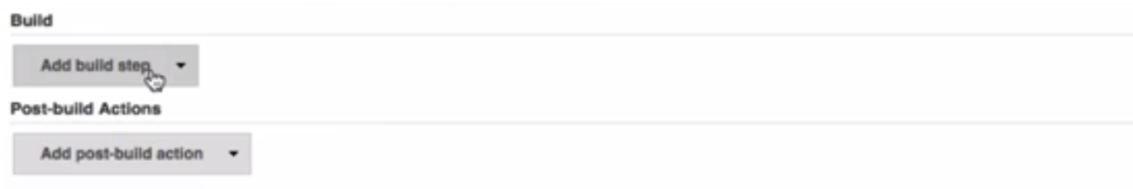

Choose Execute shell

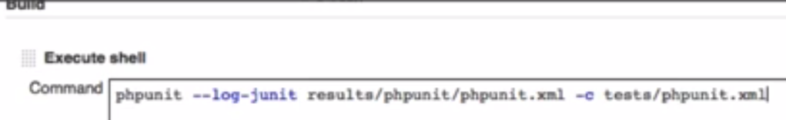

and in Post build action Publish JUnit Test result report, the same path that was set in execute shell step –

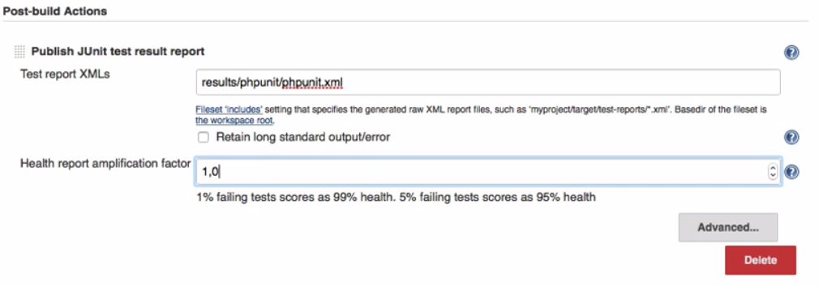

d